SQL script that creates 5 tables, populates them with sample data, and runs all required SQL operations from start to finish as per Assignment requirements.

**Step 1: Database Setup**

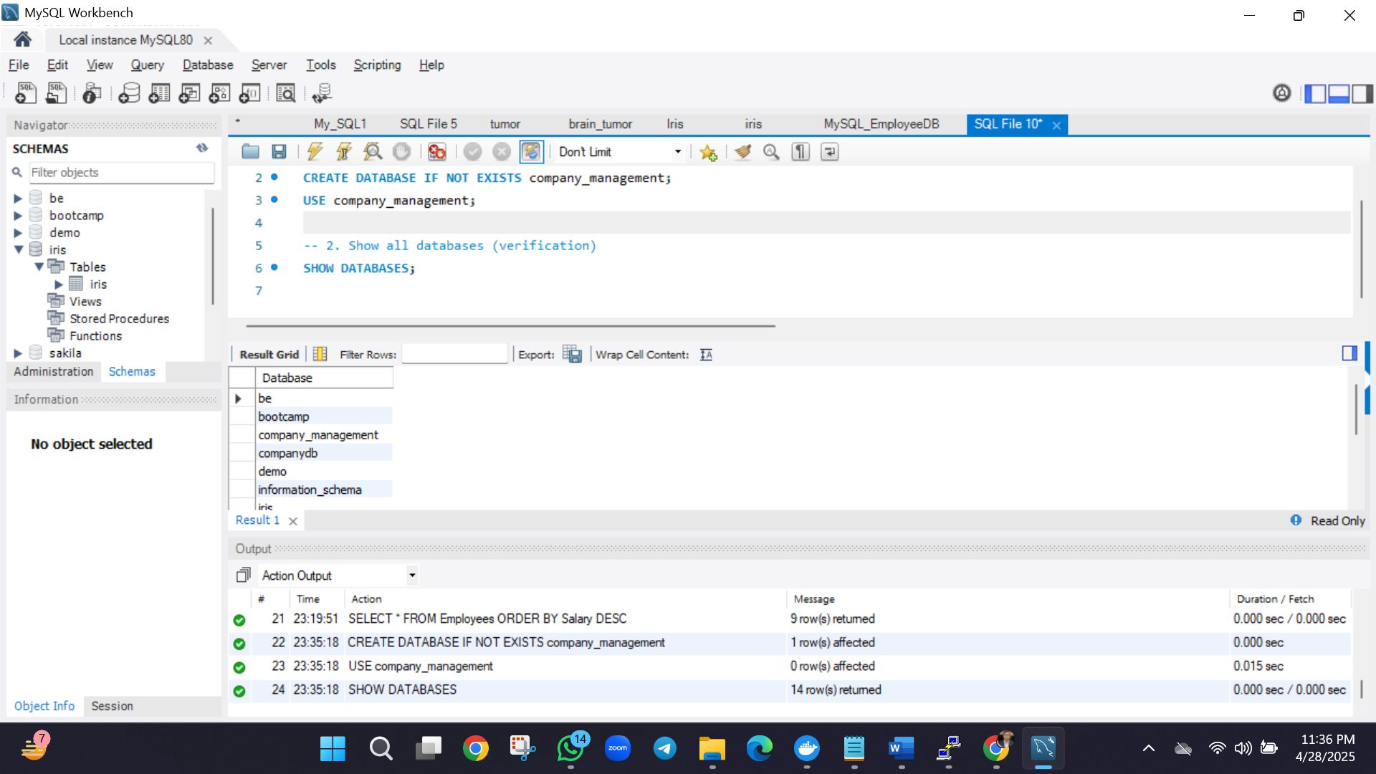

**Step 2: Create All 5 Tables**

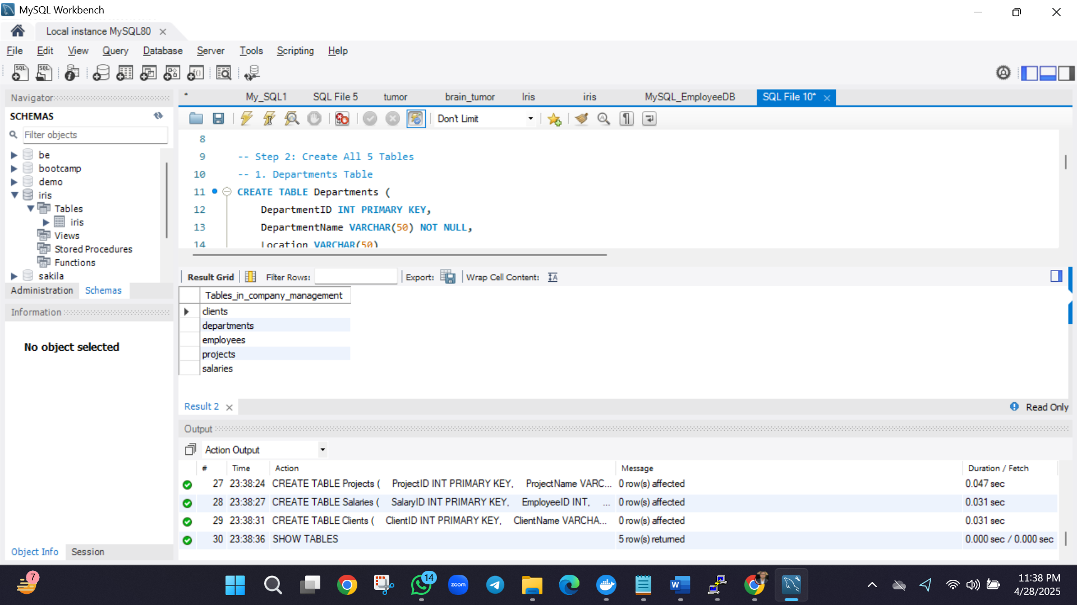

**Step 3: Insert Sample Data (10+ Records per Table)**

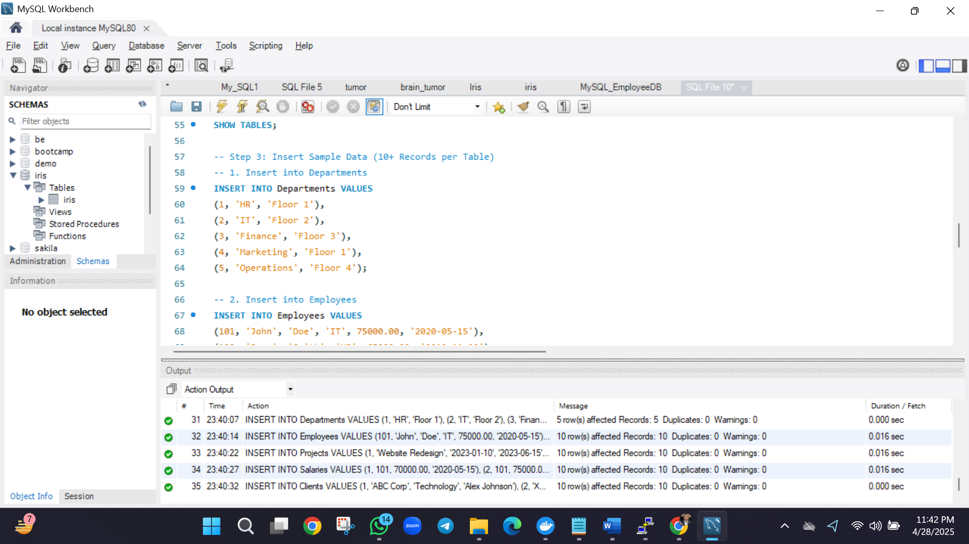

**Step 4: Run Required SQL Operations**

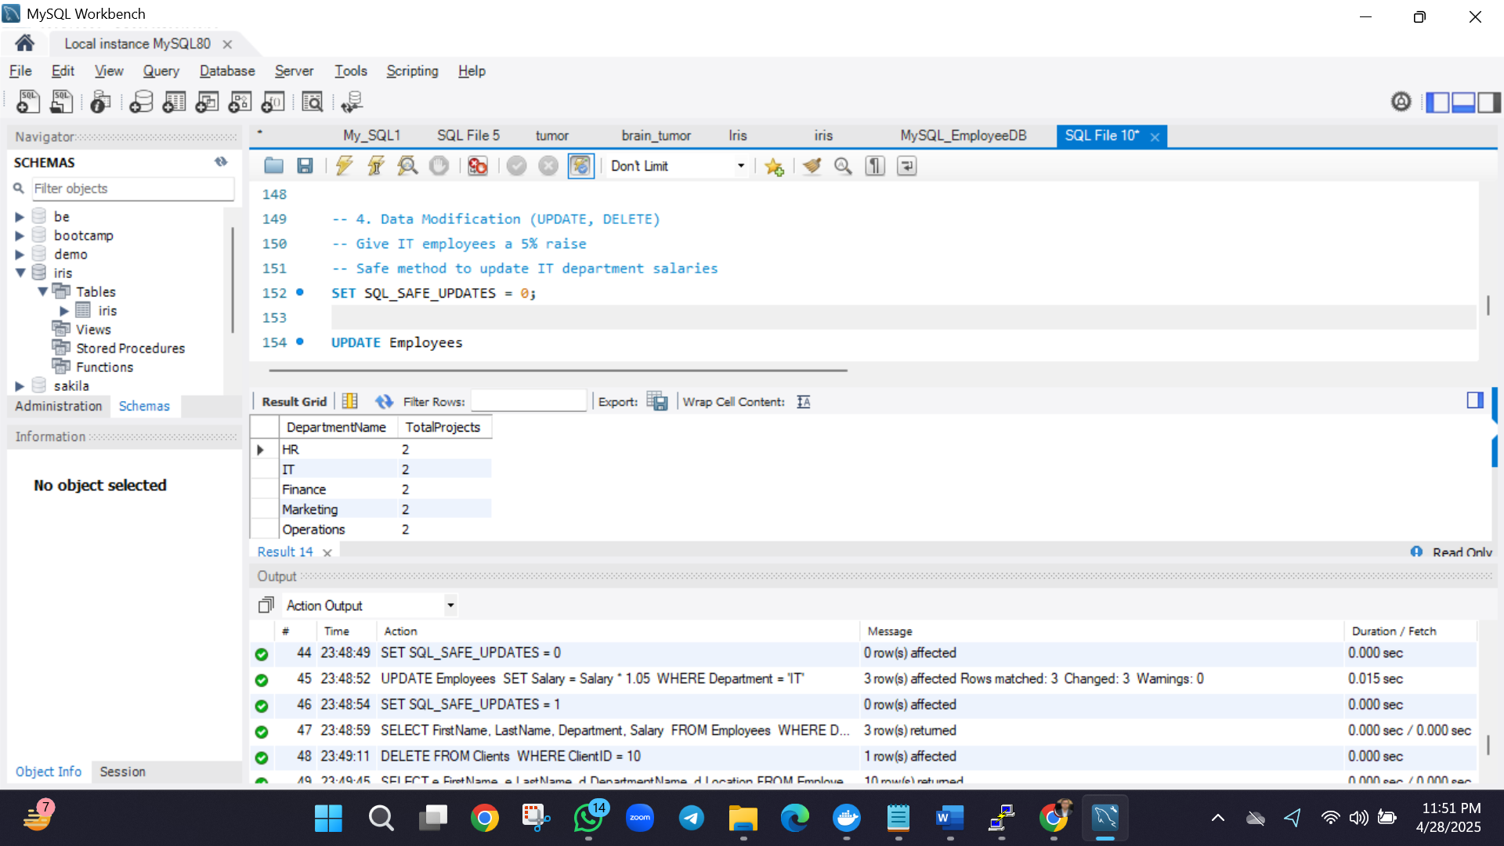

**Step 5: Verification & Cleanup (Optional)**

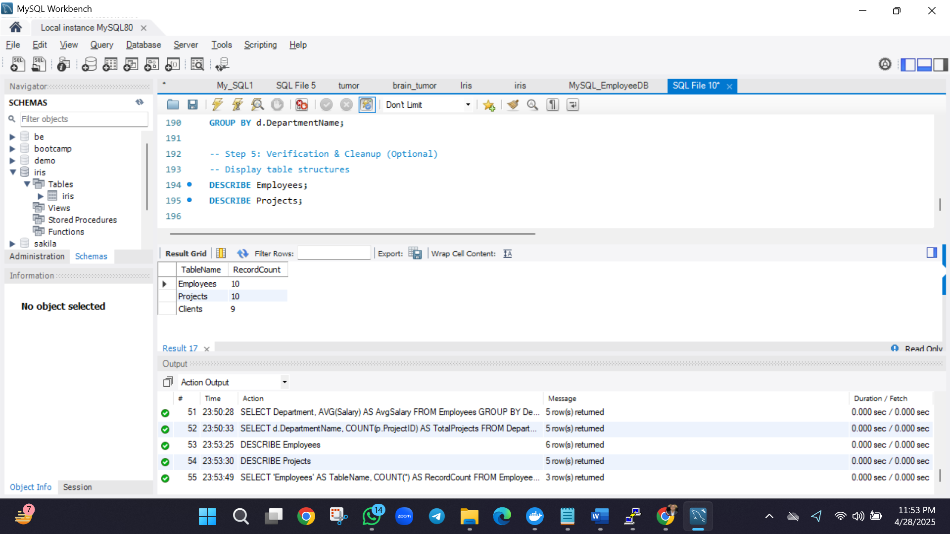

**Final Submission Checklist**

✅ **Executed all SQL commands successfully**  
✅ **Created 5 tables with proper structure**  
✅ **Inserted 10+ records in each table**  
✅ **Performed all required operations (SELECT, INSERT, UPDATE, DELETE, JOIN, GROUP BY)**  
✅ **Saved script as**.sql**file**  
✅ **Included screenshots of outputs**